Supplement

eMethods
- Training and Hyperparameter Tuning
- Temporal Test Set Construction and Threshold Selection
- Integrated Gradients for Code-Level Attribution
- Ablation Analyses
  - Transformer Blocks
  - Deep Sets vs Permutation-Variant Flattening Comparator
  - Demographic and Socioeconomic Inputs

eTables
- Hyperparameter Configurations Used in Models
- Performance Comparison for 30-Day Mortality Including Index-Hospital Death
- Ablation Study Results
- (A) Addition of Transformer Blocks
- (B) Replacement of Deep Sets With Flattening Comparator
- (C) Removal of Demographic and Socioeconomic Inputs (ICD-Only)

eFigures
- Permutation-invariant ICD Embedding Model
- Top ICD-10-CM Codes by Integrated Gradients for 30-Day Mortality Including Index-Hospital Death
- Calibration Reliability Plots for Temporal Test Set Predictions
- 30-Day Readmission
- 30-Day Postdischarge Mortality
- Web Calculator Interface Examples

eMethods 1. Training and Hyperparameter Tuning

Models were trained using batch size 128 for 10 epochs with the Adam optimizer at a learning rate of 2e-5. Early stopping was applied with patience of 2 epochs, retaining the checkpoint with the best validation performance. To address outcome imbalance, we randomly downsampled majority-class encounters in the training set to achieve a target case-control ratio of 1:1 (validation data and temporal test evaluation subsample were not downsampled). Because majority-class downsampling changes the effective outcome prevalence and can bias predicted probabilities, we performed adjustment with the original downsampling ratio of the training set and use the readjusted model outputs in all metrics/plots and for the web calculator. Random seeds for the train/validation split, downsampling, and model initialization were set to ensure reproducibility.

Hyperparameters were tuned via random search (32 trials per outcome). eTable 1reports the selected configurations. Hyperparameter definitions: d_{embed} (ICD embedding dimension); d_{hidden} (Deep Sets hidden dimension); r_{deepset} × d_{hidden} (Deep Sets output dimension); n_{encode} and n_{decode} (numbers of Deep Sets encoding/decoding layers); d_{demo} (first-layer width of the demographic/socioeconomic MLP; second layer set to d_{demo}/2); d_{mlp} (first-layer width of the predictor MLP, halving each layer to a minimum of 32 over 4 layers); r_{dropout} (dropout rate). Model selection prioritized validation AUROC; recall-weighted metrics (including F2) were used as secondary criteria.

eMethods 2. Temporal Test Set Construction and Threshold Selection

Temporal testing used eligible 2021-2022 data. To enable computationally feasible evaluation while preserving outcome prevalence, we created the temporal test evaluation subsample by stratified random sampling of the combined eligible 2021-2022 cohort, sampling 10% of outcome-positive and 10% of outcome-negative discharges for each outcome. This yielded approximately 3.2 million discharges for primary performance evaluation. Interpretability analyses used the same temporal test evaluation subsample.

Binary classification thresholds for each model were selected on the validation set by maximizing the Youden index (sensitivity + specificity − 1) and then applied unchanged to the temporal test evaluation subsample.

eMethods 3. Integrated Gradients for Code-Level Attribution

Integrated Gradients (IG) was used to quantify code-level influence on model predictions. The baseline input was defined as a neutral input corresponding to an empty diagnosis list (ie, no diagnosis codes). The straight-line interpolation path from baseline to the observed input was discretized into 32 steps. At each step, gradients of the model logit were computed with respect to diagnosis embeddings; gradients were accumulated across steps and summed across embedding dimensions to yield a scalar attribution per code occurrence. Attribution values retained sign, with positive values indicating higher predicted risk and negative values indicating lower predicted risk. To reduce instability from rare codes, ICD-10-CM codes with fewer than 50 total occurrences in the temporal test evaluation subsample were excluded from ranked summaries. For each outcome, we reported the 10 codes with the largest mean positive attributions and the 10 codes with the largest mean negative attributions.

eMethods 4. Ablation Analyses
eMethods 4.1 Transformer blocks

To evaluate whether attention-based contextualization improves performance, we added three multi-head transformer blocks operating over individual ICD embeddings. Each block followed a standard transformer design with multi-head attention, residual connections, normalization, and feed-forward sublayers. We used 3 attention heads, dropout 0.3, embedding dimension d_{embed}, and feed-forward dimension 4 × d_{embed}.

Comparative results are shown in eTable 3, Panel A. Across both outcomes, transformer blocks did not materially improve AUROC and F2 score relative to the base model. Reported P values for AUROC differences were P < .001 for readmission and P = 0.57 for postdischarge mortality.

eMethods 4.2 Deep Sets vs permutation-variant flattening comparator

To test whether permutation invariance via Deep Sets reduced predictive performance, we compared the base model with a permutation-variant alternative: a flattening layer that converts the 2-dimensional ICD embedding matrix into a 1-dimensional vector, followed by two MLP layers with d_{hidden} and r_{deepset} * d_{hidden} units to mirror the Deep Sets hidden/output sizes.

Results are shown in eTable 3, Panel B. The base Deep Sets models outperformed the flattening comparators on AUROC and F2 score. Reported P values for AUROC differences were P <.001 for readmission and P = 0.014 for postdischarge mortality.

eMethods 4.3 Demographic and socioeconomic inputs

To evaluate the incremental value of non-diagnosis covariates, we removed the 2-layer demographic/socioeconomic MLP and trained ICD-only variants.

Results are shown in eTable 3, Panel C. ICD-only variants had slightly worse AUROC and F2 score. Reported P values for AUROC differences were P=0.020 for readmission and P<.001 for postdischarge mortality.

eTable 1: Hyperparameter configurations used in models
 | d_{embed} | d_{hidden} | r_{deepset} | n_{encode} | n_{decode} | d_{demo} | d_{mlp} | r_{dropout}
30-days readmission | 32 | 416 | 0.5 | 1 | 3 | 64 | 480 | 0.1
30-days postdischarge mortality | 64 | 320 | 0.6 | 2 | 1 | 64 | 384 | 0.1
30-days mortality including index hospital death | 64 | 416 | 0.8 | 3 | 3 | 64 | 448 | 0.4
*The model configurations are determined through hyperparameter tuning for each outcome variable, respectively. All models share the same batch size and learning rate.

eTable 2. Performance comparison for 30-day mortality including index-hospital death
Methods | AUC-ROC | Precision | Recall | F1 | F2
ICD Model | 0.9651 [0.9647, 0.9656] | 0.2107 | 0.9165 | 0.3427 | 0.5489
CCI | 0.7217 [0. 7203, 0. 7231] | 0.0663 | 0.627 | 0.12 | 0.2331
CCI Age-Adjusted | 0.7501 [0. 7489, 0. 7513] | 0.0724 | 0.6043 | 0.1294 | 0.2448
ECI | 0.6158 [0.6139, 0.6177] | 0.0637 | 0.4427 | 0.1114 | 0.2022

eTable 3. Ablation study results
(A) Addition of transformer blocks
Outcome Variable | Model Variant | AUC-ROC | AUC-ROC CI | Precision | Recall | F1 | F2
30-day readmission | Full Model | 0.7496 | [0.7488, 0.7504] | 0.1881 | 0.8006 | 0.3046 | 0.4848
 | 3 Transformer Blocks | 0.7472 | [0.7464, 0.7479] | 0.1974 | 0.7565 | 0.3131 | 0.4829
30-day postdischarge mortality | Full Model | 0.8557 | [0.8532, 0.8581] | 0.0111 | 0.8756 | 0.0220 | 0.0530
 | 3 Transformer Blocks | 0.8547 | [0.8523, 0.8572] | 0.0114 | 0.8662 | 0.0225 | 0.0542

(B) Replacement of Deep Sets with flattening comparator
Outcome Variable | Model Variant | AUC-ROC | AUC-ROC CI | Precision | Recall | F1 | F2
30-day readmission | Full Model | 0.7496 | [0.7488, 0.7504] | 0.1881 | 0.8006 | 0.3046 | 0.4848
 | Without DeepSet | 0.7474 | [0.7466, 0.7482] | 0.1933 | 0.7724 | 0.3092 | 0.4829
30-day postdischarge mortality | Full Model | 0.8557 | [0.8532, 0.8581] | 0.0111 | 0.8756 | 0.0220 | 0.0530
 | Without DeepSet | 0.8513 | [0.8488, 0.8538] | 0.0108 | 0.8777 | 0.0214 | 0.0515

(C) Removal of demographic and socioeconomic inputs (ICD-only)
Outcome Variable | Model Variant | AUC-ROC | AUC-ROC CI | Precision | Recall | F1 | F2
30-day readmission | Full Model | 0.7496 | [0.7488, 0.7504] | 0.1881 | 0.8006 | 0.3046 | 0.4848
 | ICD Inputs Only | 0.7483 | [0.7475, 0.7490] | 0.1907 | 0.7868 | 0.3070 | 0.4842
30-day postdischarge mortality | Full Model | 0.8557 | [0.8532, 0.8581] | 0.0111 | 0.8756 | 0.0220 | 0.0530
 | ICD Inputs Only | 0.8483 | [0.8457, 0.8509] | 0.0110 | 0.8627 | 0.0218 | 0.0525

eFigure 1: Permutation-invariant ICD Embedding Model
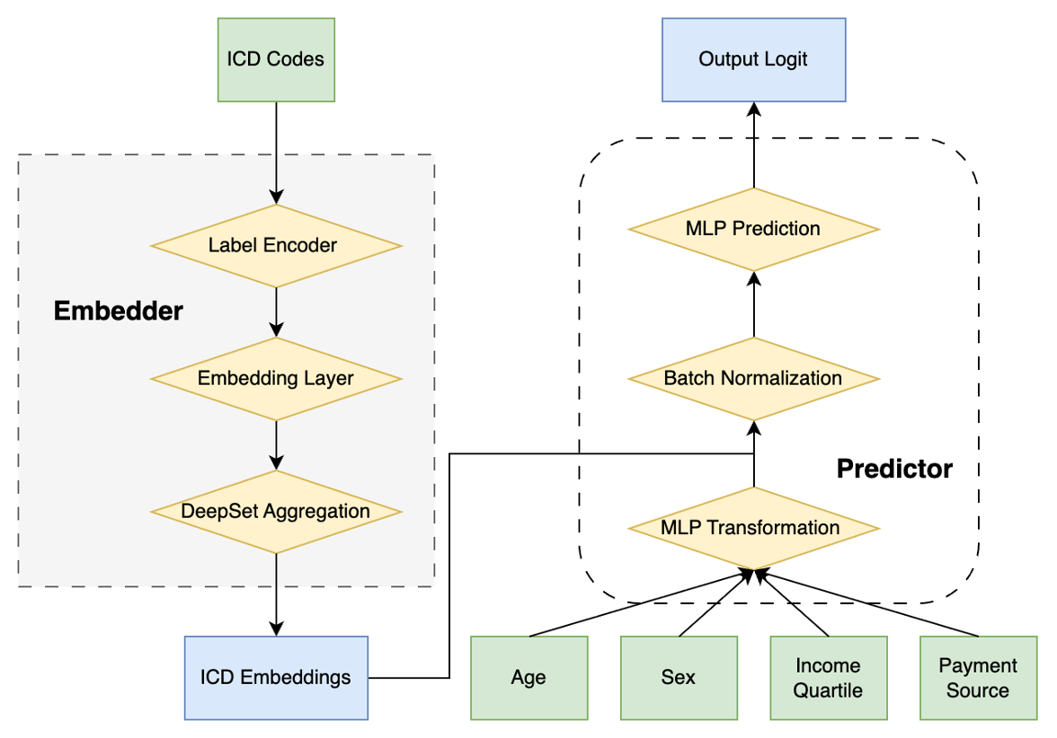
*Given a patient’s ICD-10-CM diagnosis codes together with demographic and socioeconomic features, the model estimates risk of 30-day readmission and 30-day postdischarge mortality. Diagnosis codes are embedded and aggregated with a Deep Sets module, then combined with other inputs to generate the final prediction.

eFigure 2: Top ICD-10-CM codes by Integrated Gradients for 30-day mortality including index-hospital death.
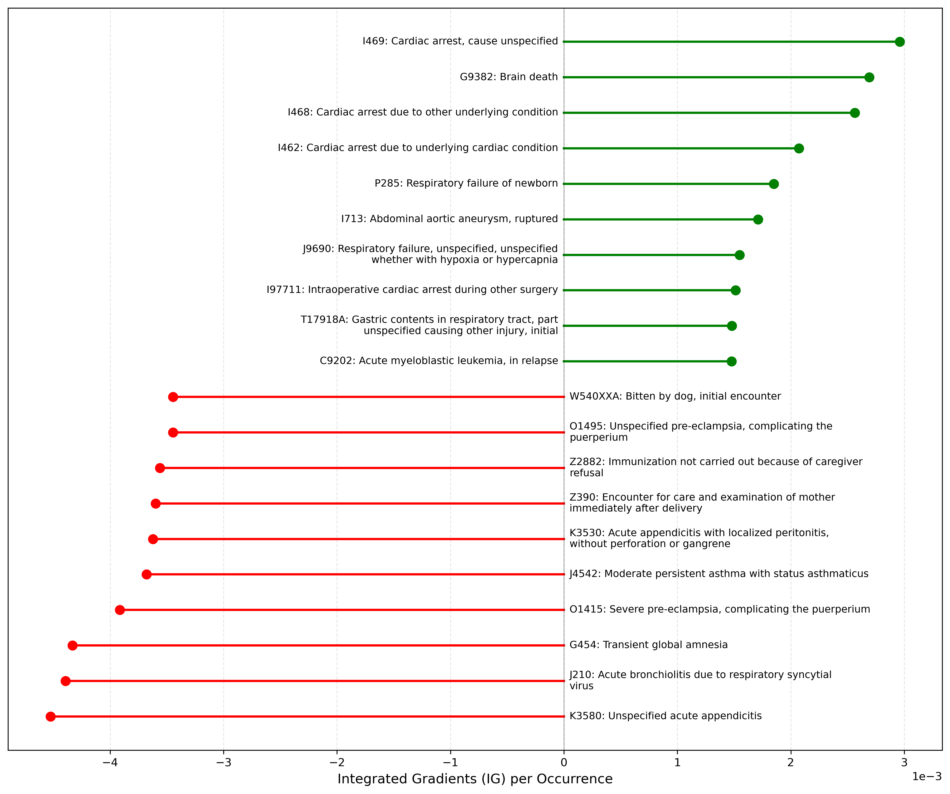

eFigure 3. Calibration reliability plots for temporal test evaluation subsample predictions. (A) 30-day unplanned readmission and (B) 30-day postdischarge mortality

eFigure 4. Web Calculator Interface Examples. (A) With demographics and (B) Without demographics
(A)
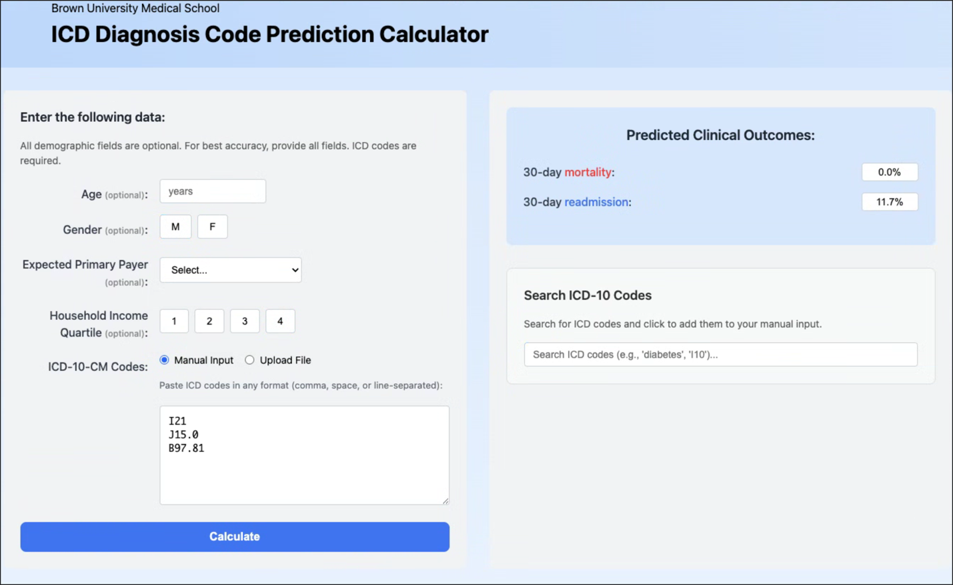
(B)
